**Name:-Prakhar,subj:-oops,class:-fintech,roll no:-f34,section:-b**

1. Difference beteen c and c++.

Ans.

**C :-**

1. C was developed by dennis Ritchie between the year 1969 and 1973 at AT&T bell labs.

2. C does not support polymorphism,encapsulation,and inheritance .

3. C is subset of c++.

4. C contains 32 keywords.

5. Data and function are separated in c.

6. Built in data types is supported in c.

**C++:-**

1. C++ was developed by bjarnestroustrup in 1979.

2. C++ supports polymorphism,encapsulation and inheritance.

3. C++ is a superset of c.

4. C++ contains 63 keywords.

5. Data and functions are encapsulated together in form of object in c++.

6. 6.built in data & user define data types is supported in c++.

**2)Define features of c++**

Ans. **There are various features of C++ such as,**

Object Oriented.

Simple.

Platform Dependent.

Mid-level programming language.

Structured programming language.

Rich Library.

Memory Management.

Powerful & Fast

Syntax base language

**3)define rules of constructor**

Ans. **The rules for writing a constructor functions are given below**

**They should be declared in the public section.**

**They are invoked automatically when the objects are created.**

**They should not have return types, therefore they cannot return values.**

**They cannot be inherited.**

**They can have default arguments.**

**Cannot refer to addresses**

**Class name and constructor name should be same**

**4) attempt any six out of seven**

**[1] tilde ( ~ ) sign is used for destructor.**

**[2] There are two types of operator overloading:**

**1. Function overloading.**

**2. Operator overloading**

**[4] #include<iostream> is used as a header file in c++.**

**[5] OOPS- object oriented programming structure.**

**[6]true**

**[7]object oriented programming**

**5)create c++ program(30marks)**

#include<iostream>

using namespace std;

class vehicle

{

public:

string bk,accelerator;

void insert()

{

cout<<"disk break is available"<<bk<<endl;

cout<<" accelerator is available"<<accelerator<<endl;

}

};

class bike:public vehicle

{

public:

int bp;

string bn;

void bikes()

{

cout<<"This is sport bike."<<bn<<endl;

cout<<" the price of the bike is 300000."<<bp<<endl;

}

};

class car:public vehicle

{

public:

int cpr;

string cn;

void cars()

{

cout<<"This car is swift."<<cn<<endl;

cout<<"car price is 1000000."<<endl;

}

};

int main()

{

vehicle v;

bike b;

car c;

v.insert();

b.bikes();

c.cars();

return 0;

}

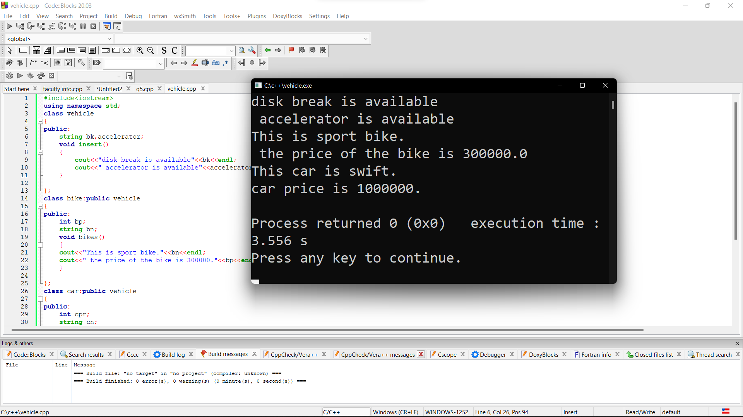

6)parameterized constructor

#include<iostream>

using namespace std;

class edu

{

public:

string fname,add,city,gender;

long int phone;

edu()

{

cout<<"default constructor"<<endl;

}

edu(string i,string j,string k,string l,long int m)

{

fname=i;

add=j;

city=k;

gender=l;

phone=m;

}

void disp()

{

cout<<"####################################"<<endl;

cout<<"faculties Name is. "<<fname<<endl;

cout<<"faculty's address is "<<add<<endl;

cout<<"faculty's city is "<<city<<endl;

cout<<"faculty's gender is "<<gender<<endl;

cout<<"faculty's phone number is "<<phone<<endl;

cout<<"####################################";

}

};

int main()

{

edu e,e1("Prakhar","5581 siromani bunglows","Ahmedabad","Male",69854785);

e1.disp();

return 0;

}

